Market Implementation Committee
PJM Conference & Training Center, Audubon, PA
February 8, 2017
9:00 a.m. – 4:00 p.m. EPT

Administration (9:00-9:15)
Welcome, announcements and review of the Antitrust, Code of Conduct, and Public Meetings/Media Participation Guidelines – Ms. Christina Stotesbury

A Special Session of the MIC to provide education on Market Operations Price Transparency has been scheduled for February 24, 2017 from 1:00 – 4:00 p.m. in the PJM Conference & Training Center.

The committee will be asked to approve draft minutes from the January 11, 2016 Market Implementation Committee meeting.

Review MIC Issue Tracking

Endorsements/Approvals (9:15-9:30)
NCEMC Problem Statement and Issue Charge Revised (9:15-9:30)
Mr. Ray Fernandez, PJM, will review a revised problem statement and issue charge that was approved by the Market Implementation Committee in January. The committee will be asked to approve the revised problem statement and issue charge.

Working Issues (9:30-10:30)
Annual Revenue Requirements for new Black Start Units (9:30-10:00)
- Mr. Tom Hauske, PJM, will continue the discussion on Annual Revenue Requirements for new Black Start units and present an updated solution option for consideration.
- Dr. Joe Bowring, Monitoring Analytics, will present information on Minimum Take Suction Levels (MTSL) costs and present a new solution option for consideration.
Issue tracking: Annual Revenue Requirements for new Black Start Units

Spot-in Transmission Service for Energy Imports from NYISO (10:00-10:30)
Mr. Chris Pacella, PJM, will review the package solutions previously presented.
Issue Tracking: Spot-in Transmission Service for Energy Imports from NYISO

Break (10:30-10:40)

Additional Updates (10:40-2:45)
- FERC Activity (10:40-12:00)
- FERC Transition Impact on PJM
Ms. Jen Tribulski, PJM, will provide an update on the FERC transition and possible implications to PJM.

- NOPR: Uplift Cost Allocation & Transparency
Ms. Rebecca Stadelmeyer, PJM, will provide an update on the FERC Notice of Proposed Rulemaking addressing Uplift Cost Allocation and Transparency.
- Order 831: Offer Caps
Mr. Adam Keech, PJM, will provide a brief update on timelines associated with the implementation of Order 831.
- Hourly Offers Order and Fuel Cost Policy Update
Ms. Lisa Morelli, PJM, will provide an update on the Hourly Offers Order (Docket No. ER16-372-002) and Mr. Jeff Schmitt, PJM, will review the associated impact to Fuel Cost Policies.
- GDF SUEZ Energy Marketing Settlement
Mr. Stan Williams, PJM, will provide a brief update on the FERC’s decision related to the GDF SUEZ Energy Marketing manipulation claim.

Lunch (12:00-1:00)

- Nodal Load Aggregates for Settlement (1:00-1:10)
Mr. Ray Fernandez, PJM, will provide an update on Load Serving Entities (LSEs) that elected to have their load priced at a nodal aggregate effective June 1, 2017.

- Calculation of Incremental Auction Revenue Rights for RTEP Upgrades (1:10-1:20)
Ms. Xu Xu, PJM, will provide an update on the calculation of Incremental Auction Revenue Rights for upgrades in the Regional Transmission Expansion Plan 2017/2018 planning year.

- FTR Forfeiture Update (1:20-1:40)
Mr. Asanga Perera, PJM, will provide an update on FTR forfeitures.

- FTR/ARR Order (1:40-1:50)
Mr. Brian Chmielewski, PJM, will provide an update on the recent FERC Order impacting the annual ARR/FTR process.
- Load Management Performance (1:50-2:00)
Mr. Jack O’Neill, PJM, will provide an update on the Load Management Performance Report behalf of Demand Response Operations.

- PJM Net Energy Injections Quarterly Report (2:00-2:10)
Mr. Ken Schuyler, PJM, will provide an update on the 2016 4th quarter Net Energy Injections report.

- 3rd Incremental Auction (2:10-2:30)
Mr. Jeff Bastian, PJM, in response to a request received at the January MIC, will provide an update on details related to the 10,000 MW from the 3rd Incremental Auction Planning Parameters.

- Inter-Regional Coordination (2:30-2:45)
Mr. Tim Horger, PJM, will provide an update on Inter-Regional Coordination activity.

Informational Section
Credit Subcommittee (CS)
Meeting materials will be posted to the CS website.

Demand Response Subcommittee (DRS)
Meeting materials will be posted to the DRS web site.

Interface Definition Update
An updated NYIS definition is posted for informational purposes only. Mr. Tim Horger, PJM, will be available to answer questions.

Intermittent Resources Subcommittee (IRS)
Meeting materials will be posted to the IRS web site.

Market Settlements Subcommittee (MSS)
Meeting materials are posted to the MSS web site.

Report on Market Operations
The Report on Market Operations will be reviewed during the MC Webinar.

Future Meeting Dates
March 8, 2017 | 9:00 a.m. | PJM Interconnection – Conference & Training Center
April 12, 2017 | 9:00 a.m. | PJM Interconnection – Conference & Training Center
May 3, 2017 | 9:00 a.m. | PJM Interconnection – Conference & Training Center
June 7, 2017 | 9:00 a.m. | PJM Interconnection – Conference & Training Center
July 12, 2017 | 9:00 a.m. | PJM Interconnection – Conference & Training Center
August 9, 2017 | 9:00 a.m. | PJM Interconnection – Conference & Training Center
September 13, 2017 | 9:00 a.m. | PJM Interconnection – Conference & Training Center
October 11, 2017 | 9:00 a.m. | PJM Interconnection – Conference & Training Center
November 8, 2017 | 9:00 a.m. | PJM Interconnection – Conference & Training Center
December 13, 2017 | 9:00 a.m. | PJM Interconnection – Conference & Training Center

Author: Christina Stotesbury

Antitrust:
You may not discuss any topics that violate, or that might appear to violate, the antitrust laws including but not limited to agreements between or among competitors regarding prices, bid and offer practices, availability of service, product design, terms of sale, division of markets, allocation of customers or any other activity that might unreasonably restrain competition. If any of these items are discussed the chair will re-direct the conversation. If the conversation still persists, parties will be asked to leave the meeting or the meeting will be adjourned.

Code of Conduct:
As a mandatory condition of attendance at today's meeting, attendees agree to adhere to the PJM Code of Conduct as detailed in PJM Manual 34 Section 4.5, including, but not limited to, participants' responsibilities and rules regarding the dissemination of meeting discussion and materials.

Public Meetings/Media Participation:
Unless otherwise noted, PJM stakeholder meetings are open to the public and to members of the media. Members of the media are asked to announce their attendance at all PJM stakeholder meetings at the beginning of the meeting or at the point they join a meeting already in progress. Members of the Media are reminded that speakers at PJM meetings cannot be quoted without explicit permission from the speaker. PJM Members are reminded that "detailed transcriptional meeting notes" and white board notes from "brainstorming sessions" shall not be disseminated. Stakeholders are also not allowed to create audio, video or online recordings of PJM meetings.

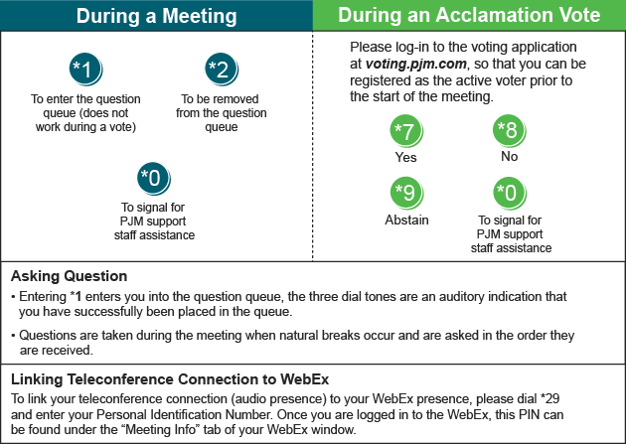
Facilitator Feedback Form: http://www.pjm.com/committees-and-groups/committees/form-facilitator-feedback.aspx

